**Tensor Flow**

**Day 3:**

1.Since, I created tables in firebase on saving it we has JSON file as follows:

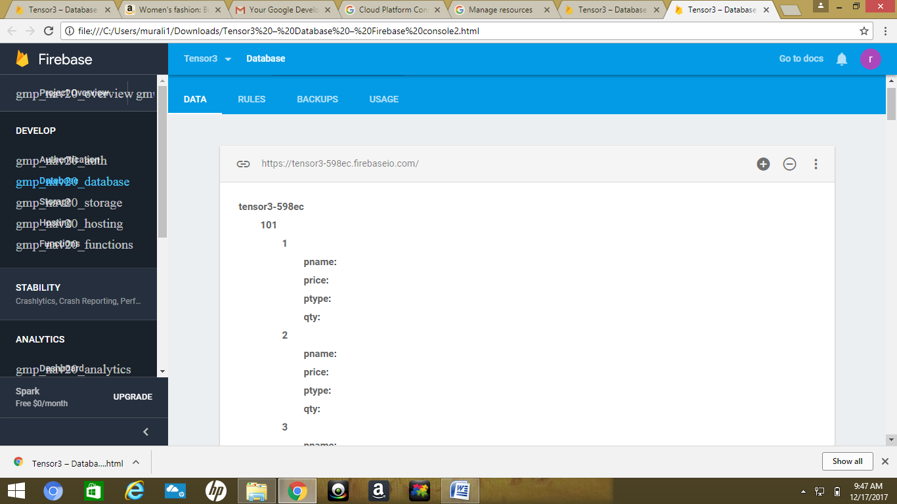

Here JSON means **Java Script Object Notation.**

The entire data of JSON is obtained in the following url: file:///C:/Users/murali1/Downloads/Tensor3%20%E2%80%93%20Database%20%E2%80%93%20Firebase%20console2.html

2.By using this data we have to create a **Tensor** **flow** model.

3.The created tensor model should analyze the data and the output of the should be the quantity

of the items that a person has brought.

4.This can be obtained by using python language.

5.Creating a code in python so that we can retrieve the quantity of the products purchased by each individual.

6. By considering the information regarding quantity, we develop an application using android studio.

7. The app takes the user login details and based on the products user purchased and the quantity of items; I should propose the things for the user what he buys.

8. Based on this future prediction of items I can suggest what the user buys.